7.81: The potential energy of a horizontal layer of thickness dy, area A, and height y is 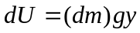. Let  be the density of water.
The total potential energy U is
